**EE3TR4 – Lab 2 Report**

**Yiming Chen, 400230266**

**Ruiyi Deng, 400240387**

[cheny466@mcmaster.ca](mailto:cheny466@mcmaster.ca)

[dengr6@mcmaster.ca](mailto:dengr6@mcmaster.ca)

Mar 5th, 2022

**Generating and Plot Message Signal**

The message signal is given by in which = 0.0005s.

Below is the plot of time domain and frequency domain of the message signal. We can see the magnitude spectrum of the message signal in the frequency domain. Also some part of the code used to generate and plot the message signal are shown below along with the plot.

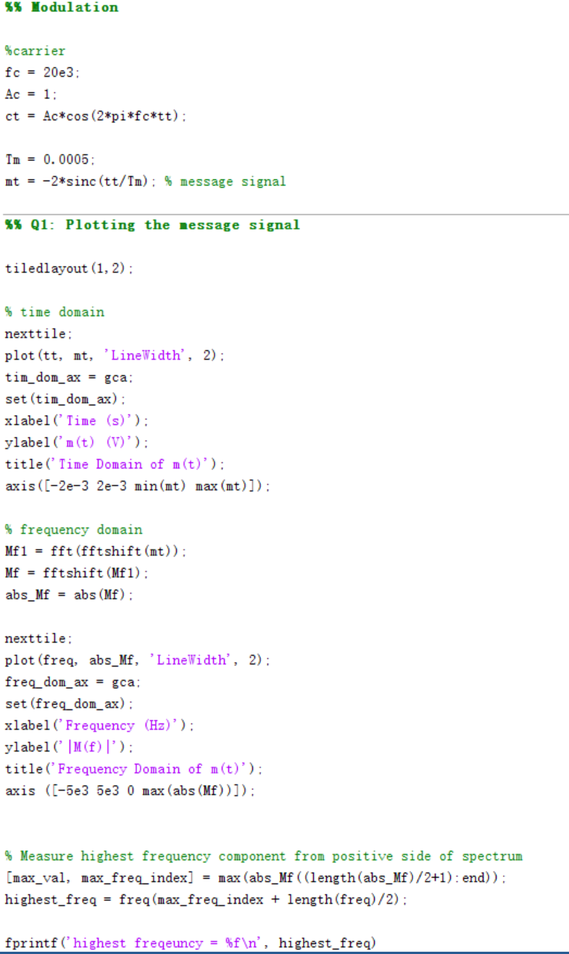

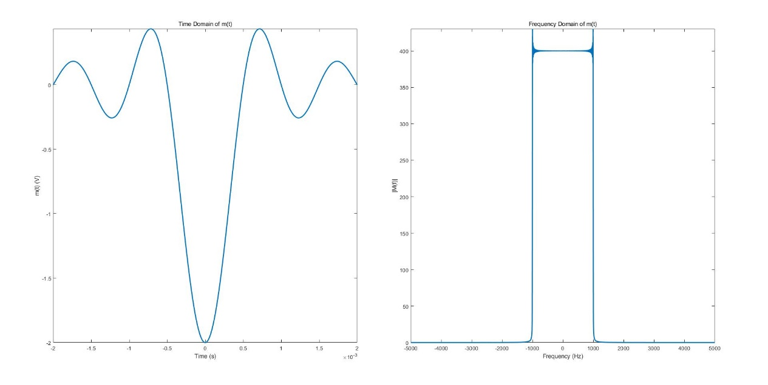

According to our calculation, the highest frequency component occurs at 995Hz, which means it is the frequency bin closest to 1000Hz. Below is the calculation procedure which we performed to calculate the magnitude spectrum of the message signal. When = 0.0005, the rect function representing the magnitude spectrum of the message signal ranges from -1000 to 1000, which matches the magnitude spectrum we plotted in MATLAB.

**Amplitude Modulation**

The modulated signal is given by . And the carrier is given by where = 1V and = 20KHz. Attached is the code to generate and plot the modulated signal.

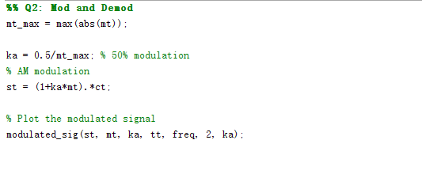

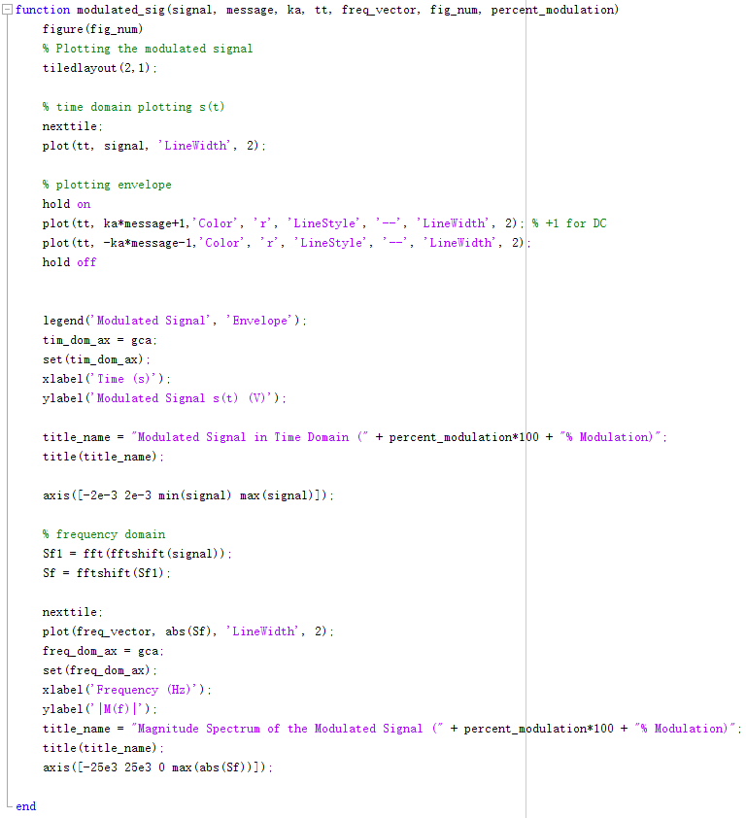

Below is the plot of the time and frequency of the modulated signal with 50% modulation. The frequency domain plot features the magnitude spectrum of the modulated signal.

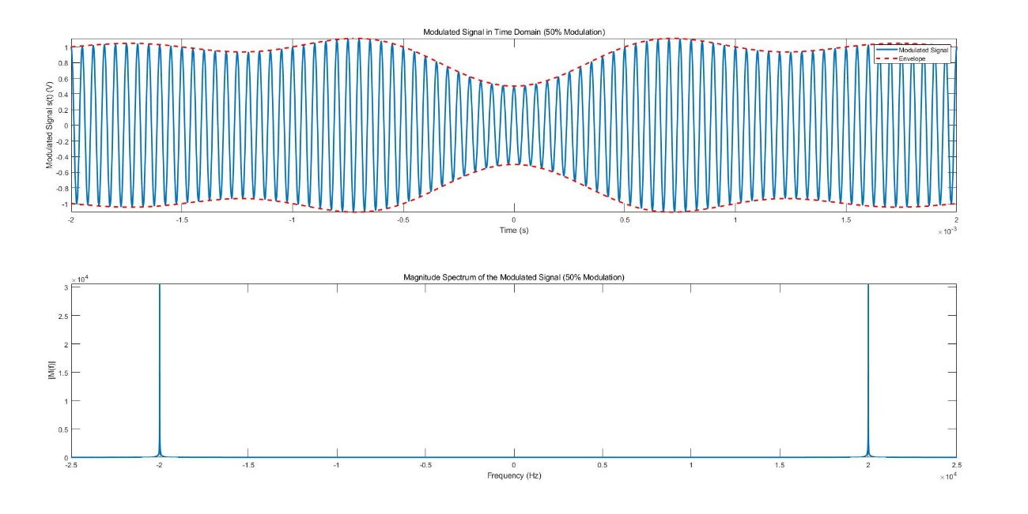

**Amplitude Demodulation**

We wrote our own function of envelope detect to remove the DC component of the modulated signal to demodulate it. Below is our envelope detect function and our output fig function. 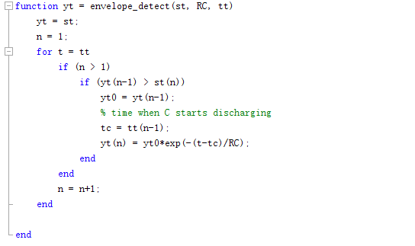

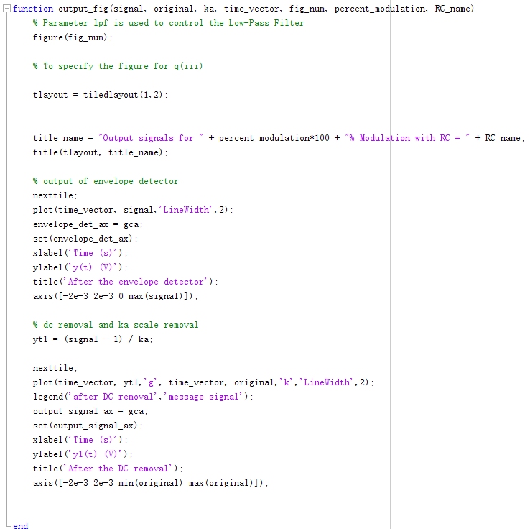

**Output Signals for Time Constant**

Below are plot of the output signals for time constant . We can see that the upper envelope of the output signal does follow the original message signal closely, but there is a significant rippling in the output signal. We may reduce the rippling by passing the signal through a low-pass filter, as rippling in the signal might give us a significant offset. Also, the rippling is possibly because the time constant set in this part is too low.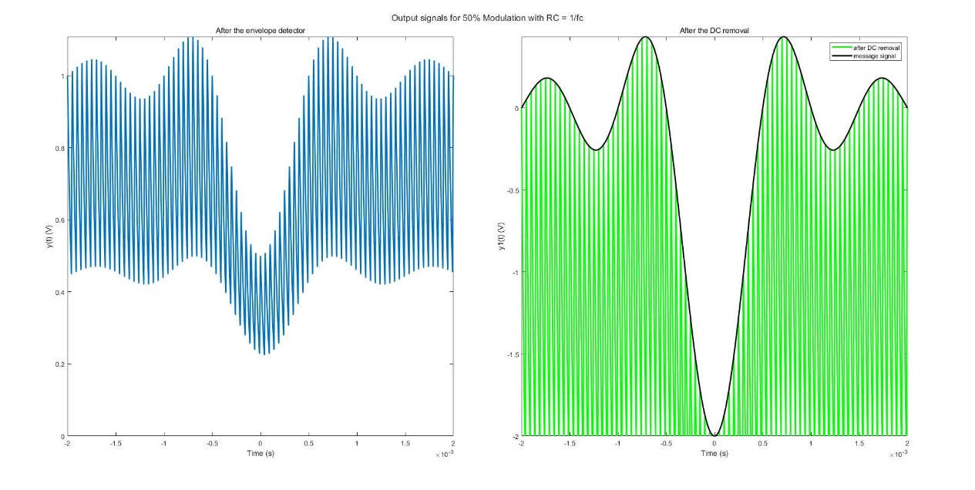

**Output Signals for Time Constant**

Below are plot of the output signals for time constant We can see that the output signal lags behind the input signal significantly whenever there is a drop in the input signal, and the curve following the increasing portions of the input signal is very jagged. When there is a drop in the input signal, it means there is a significant portion of input signal is lost, and it would be

impossible to accurately retrieve the input signal whenever the signal decreases too rapidly for the envelope to follow. The reason of above phenomenon happened may be caused by the time constant in this part is set too high.

**Output Signals for Optimal Time Constant**

After testing for several times we finally determined a approximate range for the optimal time constant which is from 1*Tm – 2*Tm. In this range, it could avoid generating dense ripples by two sides and the middle part of the signal could follow the message signal instead of cases for time constant = 10*Tm like what is shown above.

Apart from that, if we want to obtain a cleaner signal, we could apply a low pass filter to modify the ripples.

**Output Signals for Amplitude Modulation of 200%**

In this part, we changed the % of modulation to 200%. Intuitively, this will lead to the two envelopes crossing with each other. Below is the simulated result and from which the assumption is proved.

From the signal shown above it is obvious that in the crossing part, the signal fails to pass from the message signal. In other word, the envelopes ruined the demodulated signal. Thus, we deem that due to the crossing section when % of modulation over 100%, we cannot retrieve the signal from the message signal from demodulation.